**WEBSITE REVIEW**

1. Tiger Head: Make the tiger head part of the business logo.
2. Hotline: The number is +1238989444
3. Mixed capital-letter sentences should be corrected in regular sentence case.
4. Change sentences with “MyBusTaxBookkeeping” to “Business and Tax Consulting, Inc.”
5. Saw different flashing names: Ifeanyi Ewoh, Jude Nsude
6. “Certificate Program”
   1. Put the logo for the “Professional Institute of Independent Bookkeepers” (PIIB) and spell it out at the top of the page in that section
   2. On the section page, include a sample Certificate of Completion
7. “About Us” page: Replace my name and photo with the “Mark Strange” person that is there (use “My Photo 2”)
8. “Portfolio”: Use my photo which was included in my write up script
9. Under the “Search” menu, it does not take you direct to the search item
10. Change “Book Now” to “Request/Apply Now”
11. “Select a Business” pull down menu, services are mixed with training topics
12. Take out the section where it has the number of projects completed, satisfied clients, and businesses supported
13. Take out this section, or reword it:
    1. 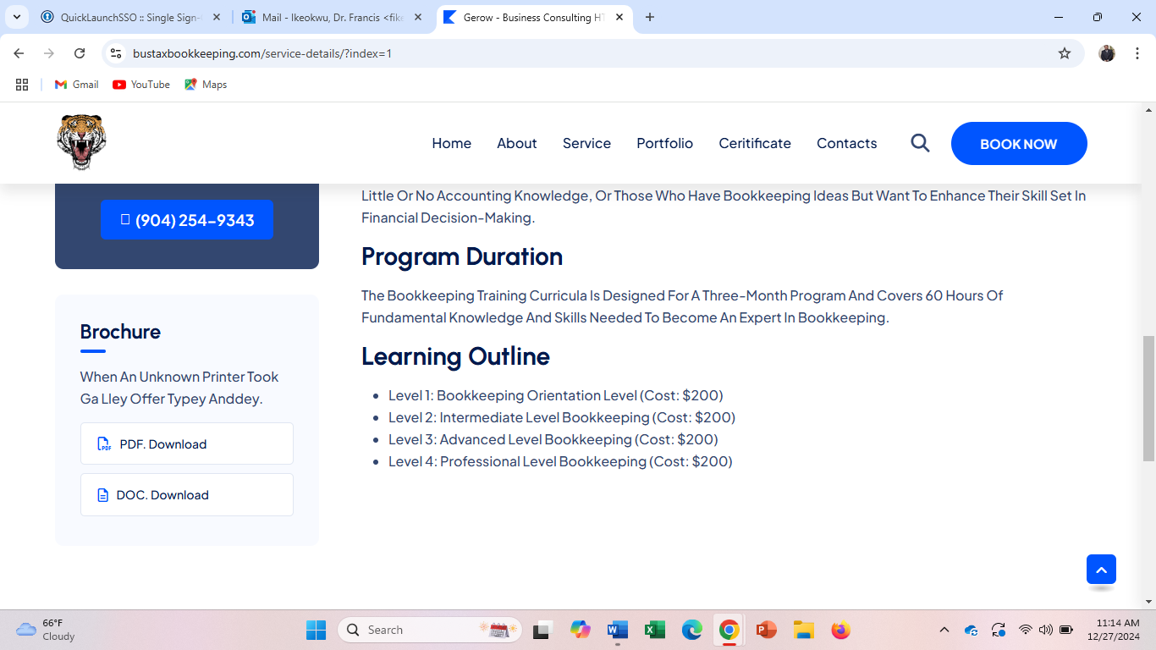
14. Every word should not be capitalized in the different paragraphs for each service detail (see below for example); in general, throughout the entire site, every word should not be capitalized
    1. 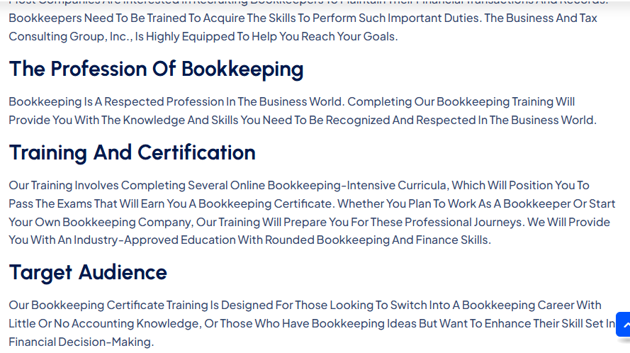
15. The Contacts/“Office Address” section needs to be changed
    1. Just add my name, phone number, P.O. Box, and your email address
       1. Can just title it as “Get in Contact”, or “Contact Information”
       2. Remove the “USA Office” and “Australia Office” subtitles
    2. Take out the Google Maps widget
16. Take out the “Creative Team” image on the homepage
17. In the “About” section, use your picture instead of a random stock photo
    1. Take out the “98% Business Goal” graph
18. Use clearer pictures of the certificates in the “Certificate” section

Photo List (photos to use for each section of the website; see attached)

1. Homepage
   1. Main Homepage: Photo A
   2. “Empowering Businesses for Success” section: Photo B
   3. “Crafting Effective Strategies for Business Success” section: Photo C
   4. “Comprehensive Solutions for Business Success” section: Photos D to G
   5. “News and Blog” section: Photos K to M
2. About Page
   1. Main photo: (the photo that is titled “**My Photo 2**”)
   2. Mission section: Photo H
3. Portfolio Section: Photo I (the photo that is titled “**My Photo 2**”)
4. Contacts Section: Photo J